34.55: a) 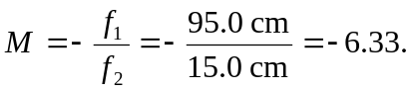
b) 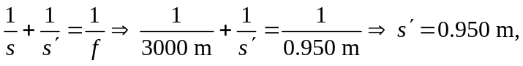 so the height of an image of a building is 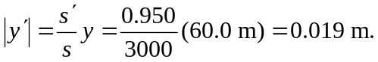
c)

